# TRINIT HACKATHON ML04

Introduction

The problem statement provided to us was to predict the stock price based on the 20+years of historical data of the company IBM.

Proposed Method

We get the data from the given api and then normalize the data. We start with a simple model of linear regression to see how it is working. Then build the front end UI.

Work Done and Results

We got the data from given API. As the data wasn’t in a data frame format. We constructed it into a suitable data frame, changed the column names into suitable names and changed the data types of the values.

We then split it into train and validation datasets, normalised the data, fit it into a linear regression model and check it’s rms which is 0.6645810361422343.

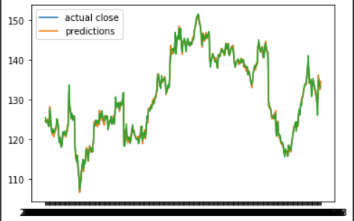

Conclusion

Even though it was a simple linear regression model, it did give pretty good results.